FOR IMMEDIATE RELEASE
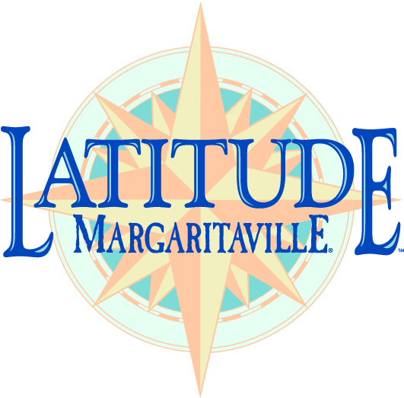
MEDIA CONTACT:
Paula Robertson
Paula Robertson & Associates
239-454-1454
Paula@prprUSA.com

Latitude Margaritaville Daytona Beach named among

25 Best Value Communities 2021 by 55places.com

Daytona Beach, FL — August 26, 2021 — Latitude Margaritaville Daytona Beach has been named as one of the “25 Best Value Communities 2021” by 55places.com — the leading resource for those searching for information about active adult communities in the United States.

To determine which of the 3,800+ communities across the country provide the best value to active adults, 55places.com reviewed communities with the lowest home prices, most square footage for the money, amenities and low taxes. Data was pulled from several sources including the National Real Estate Data from the MLS, Census Bureau, Tax Foundation and hand-curated data from 55places.com. The final list was weighed and scaled with the active adult lifestyle in mind.

Inspired by the lifestyle of singer, songwriter and best-selling author Jimmy Buffett, Latitude Margaritaville communities offer a no-worries lifestyle of fun, food, music and escapism for those 55-and-better who may be growing older, but not up. This new portfolio of active adult communities is being developed by Minto Communities and global lifestyle brand Margaritaville.

Home choices include conch cottages, villas and single-family homes priced from the mid-$200s. World-class resort style amenities at the dynamic Latitude Town Center include a state-of-the-art Fins Up! Fitness Center; lagoon-style Paradise Pool with beach-style entry and swim up Tiki Island; Latitude Bar & Chill Restaurant and Changes in Attitude Bar. A Town Square features a thatched roof bandshell with full-size concert stage, jumbo screen for live concerts and movies, and cushioned dance floor. There also are tennis and pickleball courts, a walking trail and Barkaritaville Dog Park. A private Beach Club on the Atlantic Ocean with continuous shuttle to and from the community is exclusive to residents.

Phase two amenities are scheduled to open this fall, and include a Workin’ N’ Playin’ Center where arts, crafts and other programs are offered; Last Mango Theater for shows, dances and banquets; The Hangar workshop where residents can tune up their golf carts, and Bocce ball courts. In addition, canine residents can get pampered at the Barkaritaville Pet Spa.

Latitude Margaritaville Daytona Beach was the first of the Latitude Margaritaville communities to open. Latitude Margaritaville Hilton Head, located near Hilton Head Island, South Carolina, is the second. Latitude Margaritaville Watersound, is the third to be developed by Minto and Margaritaville, and the first to be developed in partnership with The St. Joe Company.

For more information on Latitude Margaritaville and to sign up to receive regular development updates, visit www.LatitudeMargaritaville.com. Follow Latitude Margaritaville on Facebook at www.facebook.com/LatitudeMargaritaville and on Twitter at @LatitudeMville.

About Latitude Margaritaville Latitude Margaritaville is a new portfolio of active adult communities developed by master developer Minto Communities and global lifestyle brand Margaritaville Holdings. Offering resort-style amenities, Latitude Margaritaville is the ideal destination for those looking to live the Margaritaville lifestyle as they grow older, but not up. The communities feature a resort-style pool, fitness center, live entertainment, signature Margaritaville food and beverage concepts, arts and learning programs and more. Ranked the nation’s most popular active adult community of 2018 by 55Places.com and 2019’s Best 55+ Community of the Year by the National Association of Home Builders, Latitude Margaritaville communities are now open in Daytona Beach, Florida, near Hilton Head, South Carolina and in Watersound, Florida located on the Emerald Coast in Florida’s Panhandle. Additional Latitude Margaritaville communities are planned for some of the nation’s most popular destinations.

--30--

NOTE TO EDITOR: Please see Dropbox link to photos.
https://www.dropbox.com/sh/ygxfvhofnnsh2kb/AAD1oFY3t7MIaqHguNR-8EdWa?dl=0

